Additional File
Supplementary Table 1: Baseline demographic and clinical characteristics of the final analytic cohort (n=93,418) and the original total population (n=652,314), with standardized mean differences (SMD)
Characteristics | overall | total | p-value | SMD
 | 652,314 | 93,418
Age, years | 72(68,77) | 71(67,75) | ＜0.001 | 0.129
Male, n(%) =1 | 281,930(43.22) | 32,435(34.72) | ＜0.001 | 0.183
Smoking, n(%)
no | 550,226(84.35) | 82,276(88.07) | ＜0.001 | 0.111
current | 102,088(15.65) | 11,142(11.93)
Drinking, n(%)
no | 582,190(89.25) | 86,023(92.08) | ＜0.001 | 0.097
current | 70,124(10.75) | 7395(7.92)
BMI, kg/m2 | 22.83(21.01,24.84) | 24.06(21.97,25.97) | ＜0.001 | 0.256
WC, cm | 80(75,85) | 82(76,88) | ＜0.001 | 0.2
eGFR, ml/min per 1.73 m2 | 74.76(60.31,94.36) | 91.45(59.86,93.85) | ＜0.001 | 0.105

Specifically, we followed a multi-step decision process that encompasses:
Step 1: Model specification. Serial LCTMs with 2 to 5 classes were fitted, testing linear and quadratic trajectory shapes.
Step 2: Statistical criteria. The optimal number of trajectory groups was jointly determined using (i) Bayesian Information Criterion (BIC)—the model with the lowest BIC was prioritized; (ii) Akaike Information Criterion (AIC)—considered alongside BIC; (iii) average posterior probability (AvePP) —we required an AvePP ≥ 0.7 for each trajectory class, indicating good classification accuracy; and (iv) entropy (range: 0 to 1)—models with higher entropy (≥0.7) were preferred, reflecting greater class separation.
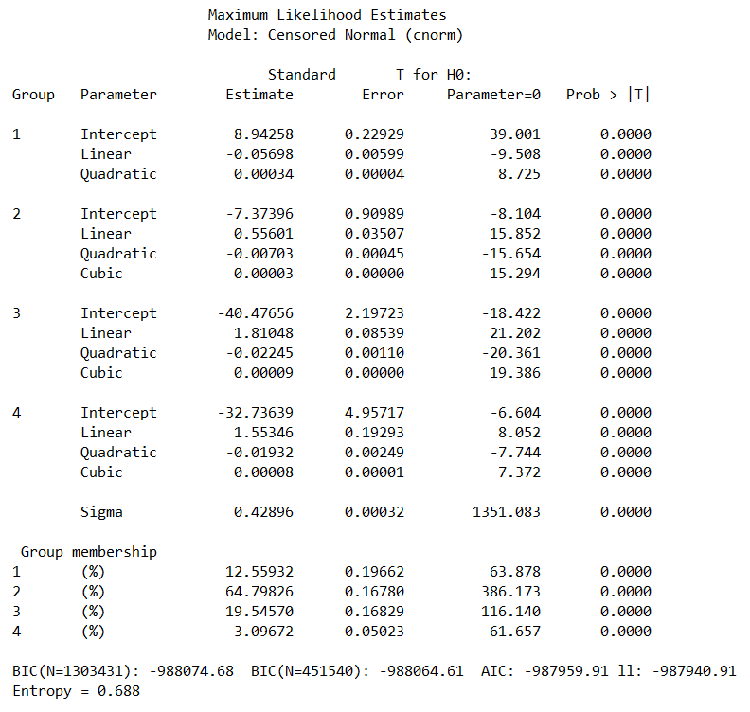
Supplementary Table 2: Model fit statistics and classification accuracy for trajectory solutions: Bayesian Information Criterion (BIC), Akaike Information Criterion (AIC), average posterior probability (AvePP), and entropy
Step 3: Model adequacy. Following the framework by Lennon et al., after selecting the candidate model based on fit statistics, we further assessed model adequacy using discrimination tools (degree of separation between classes and examination of residual plots) to ensure that the trajectories were well-differentiated. The average posterior probabilities (APPA) for each trajectory group were all above 0.7 (Group1: 0.762, Group2: 0.776, Group3: 0.837, Group4: 0.851), indicating excellent classification accuracy. Mahalanobis distances were also computed but, due to the near‑singular within‑group covariance matrices and the high‑dimensional scaling, the distances were not informative (all groups showed a mean self‑distance of approximately 2.0). We therefore rely on the more robust envelope and APPA diagnostics, which are standard in latent class trajectory modeling (Lennon et al., 2018).
Supplementary Fig. 1: Elsensohn's envelope of residuals: mean residuals by age and trajectory group with 95% confidence intervals
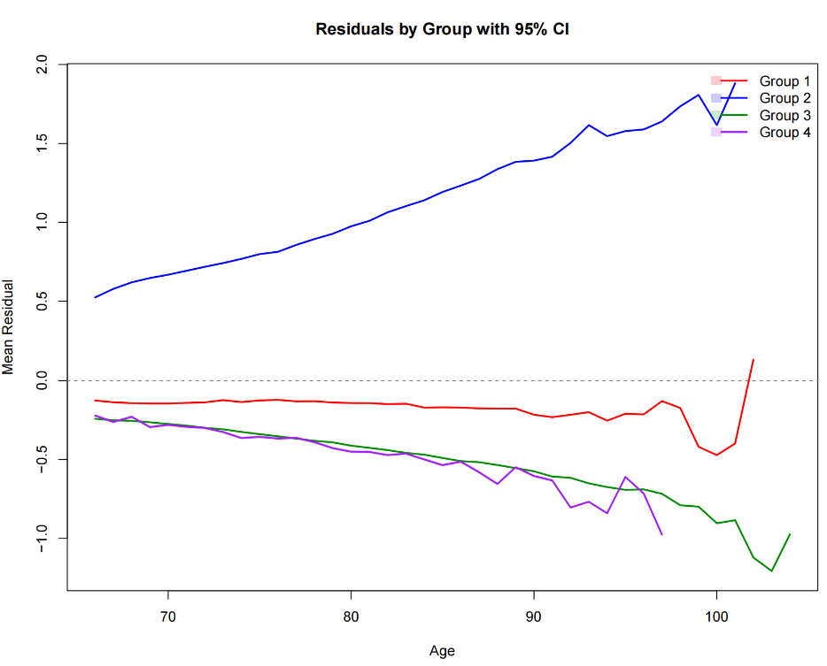
Step 4: Clinical plausibility. The final model was also evaluated on clinical grounds, i.e., whether the identified trajectory groups corresponded to biologically and clinically meaningful patterns of insulin resistance progression. This combined statistical-clinical approach has been adopted in the literature and is detailed in the revised Methods section.

Supplementary Table 3: Baseline characteristics of participants in the quartile range of the TyG index
Characteristics | total | Q1 | Q2 | Q3 | Q4 | p-value
pAge, years | 71.35±5.07 | 71.60±5.24 | 71.49±5.12 | 71.40±5.06 | 70.92±4.83 | <0.001
Male, n(%) =1 | 32,435(34.72) | 8,906(38.11) | 8,426(36.10) | 7,877(33.71) | 7,226(30.96) | <0.001
Smoking, n(%)
1（never） | 82,276(88.07) | 20,531(87.84) | 20,616(88.33) | 20,593(88.12) | 20,536(88.00) | 0.776
2（former） | 2,477(2.65) | 627(2.68) | 602(2.58) | 630(2.70) | 618(2.65)
3（current） | 8,665(9.28) | 2,214(9.47) | 2,122(9.09) | 2,146(9.18) | 2,183(9.35)
Drinking, n(%)
1（never） | 86,023(92.08) | 21,439(91.73) | 21,533(92.26) | 21,549(92.21) | 21,502(92.14) | 0.001
2（occasionally） | 4,329(4.63) | 1,096(4.69) | 1,049(4.49) | 1,100(4.71) | 1,084(4.64)
3（always） | 1,252(1.34) | 364(1.56) | 337(1.44) | 290(1.24) | 261(1.12)
4（everyday） | 1,814(1.94) | 473(2.02) | 421(1.80) | 430(1.84) | 490(2.10)
Regular exercise, n(%)
1（everyday） | 24,351(26.13) | 5,168(22.18) | 5,447(23.39) | 6,561(28.13) | 7,175(30.80) | <0.001
2（≥1 times/week） | 4,712(5.06) | 1,270(5.45) | 1,214(5.21) | 1,085(4.65) | 1,143(4.91)
3（occasionally） | 10,372(11.13) | 2,584(11.09) | 2,704(11.61) | 2,680(11.49) | 2,404(10.32)
4（never） | 53,774(57.69) | 14,277(61.28) | 13,927(59.79) | 12,995(55.72) | 12,575(53.98)
BMI, kg/m² | 24.06±3.09 | 23.52±3.01 | 23.76±2.99 | 24.26±3.11 | 24.72±3.11 | <0.001
WC, cm | 82.35±9.41 | 80.53±9.25 | 81.41±9.20 | 83.01±9.32 | 84.46±9.38 | <0.001
SBP, mmHg | 138.25±17.00 | 135.17±15.86 | 135.87±15.91 | 139.36±17.08 | 142.59±18.03 | <0.001
DBP, mmHg | 81.72±9.27 | 80.60±8.73 | 81.10±8.65 | 82.12±9.42 | 83.04±10.03 | <0.001
Fasting glucose, mmol/l | 6.77±2.62 | 5.36±1.07 | 5.88±1.16 | 6.83±1.72 | 9.02±3.76 | <0.001
Total cholesterol, mmol/l | 4.79±3.10 | 4.25±1.81 | 4.46±1.85 | 4.73±1.61 | 5.72±5.28 | <0.001
Triglycerides, mmol/l | 1.87±1.97 | 0.98±0.26 | 1.37±0.24 | 1.70±0.39 | 3.42±3.42 | <0.001
LDL, mmol/l | 2.57±0.91 | 2.38±0.82 | 2.52±0.83 | 2.67±0.90 | 2.73±1.04 | <0.001
HDL, mmol/l | 1.50±0.83 | 1.53±0.96 | 1.52±0.85 | 1.49±0.78 | 1.43±0.73 | <0.001
Serum creatinine, umol/l | 82.57±25.55 | 81.88±24.69 | 82.34±23.58 | 82.46±25.38 | 83.59±28.29 | 0.011
eGFR, ml/min per 1.73 m² | 91.45±155.74 | 92.69±155.79 | 91.13±156.46 | 91.24±155.23 | 90.75±155.47 | <0.001
Hypertension, n(%) | 70,077(75.01) | 16,033(68.60) | 16,441(70.44) | 18,203(77.89) | 19,400(83.13) | <0.001
Diabetes, n(%) | 47,291(50.62) | 7,050(30.16) | 8,983(38.49) | 13,361(57.17) | 17,897(76.69) | <0.001
Dyslipidemia, n(%) | 27,806(29.77) | 2,784(11.91) | 2,900(12.43) | 5,341(22.86) | 16,781(71.91) | <0.001
Anti-hypertensive medication, n(%) | 65,638(70.26) | 16,094(68.86) | 16,263 (69.68) | 16,643(71.22) | 16,638(71.29) | <0.001
Hypoglycemic medication, n(%) | 12,839(13.74) | 2,645(11.32) | 2,939(12.59) | 3,469(14.84) | 3,786(16.22) | <0.001
Continuous data presented as median (IQR).
Categorical data presented as number (%).
BMI, body mass index; WC, waist circumference; SBP, systolic blood pressure; DBP, diastolic blood pressure; TC, total cholesterol; TG, triglycerides; LDL, low-density lipoprotein; HDL, high-density lipoprotein; eGFR, estimated glomerular filtration rate.
Supplementary Table 4: Hazard ratios (95% confidence intervals) of all-cause mortality by baseline TyG index
TyG index | Quartile 1 | Quartile 2 | Quartile 3 | Quartile 4 | Per 1 SD
all-cause mortality(N) | 1826 | 1815 | 1798 | 1925
Unadjusted  HR (95% CI) | Reference | 1.008(0.944-1.075) | 1.017(0.953-1.086) | 1.087(1.019-1.158) | 1.023(0.990-1.057)
P value |  | 0.814 | 0.605 | 0.011 | 0.182
p for trend | 0.013
Model 1  HR (95% CI) | Reference | 1.030(0.965-1.099) | 1.063(0.996-1.135) | 1.213(1.138-1.294) | 1.079(1.045-1.114)
P value |  | 0.370 | 0.064 | 0.000 | 0.000
p for trend | 0.000
Model 2  HR (95% CI) | Reference | 1.034(0.969-1.104) | 1.079(1.011-1.151) | 1.238(1.161-1.320) | 1.088(1.054-1.123)
P value |  | 0.312 | 0.023 | 0.000 | 0.000
p for trend | 0.000
Model 3  HR (95% CI) | Reference | 1.044(0.978-1.115) | 1.110(1.039-1.186) | 1.321(1.235-1.414) | 1.189(1.144-1.235)
P value |  | 0.192 | 0.002 | 0.000 | 0.000
p for trend | 0.000
Model 4  HR (95% CI) | Reference | 1.039(0.973-1.109) | 1.108(1.037-1.184) | 1.359(1.262-1.464) | 1.129(1.088-1.171)
P value |  | 0.252 | 0.002 | 0.000 | 0.000
p for trend | 0.000
Model 1: Adjusted for age and sex;
Model 2: Adjusted for age, sex, smoking, drinking and exercise.
Model 3: Adjusted for age, sex, smoking, drinking, exercise, BMI, WC, serum creatinine, eGFR, SBP, DBP, TC, LDL and HDL.
Model 4: Adjusted for age, sex, smoking, drinking, exercise, BMI, WC, serum creatinine, eGFR, hypertension and dyslipidemia.
TyG index, triglyceride-glucose index; HR, hazard ratio; CI, confidence interval; SD, standard deviation

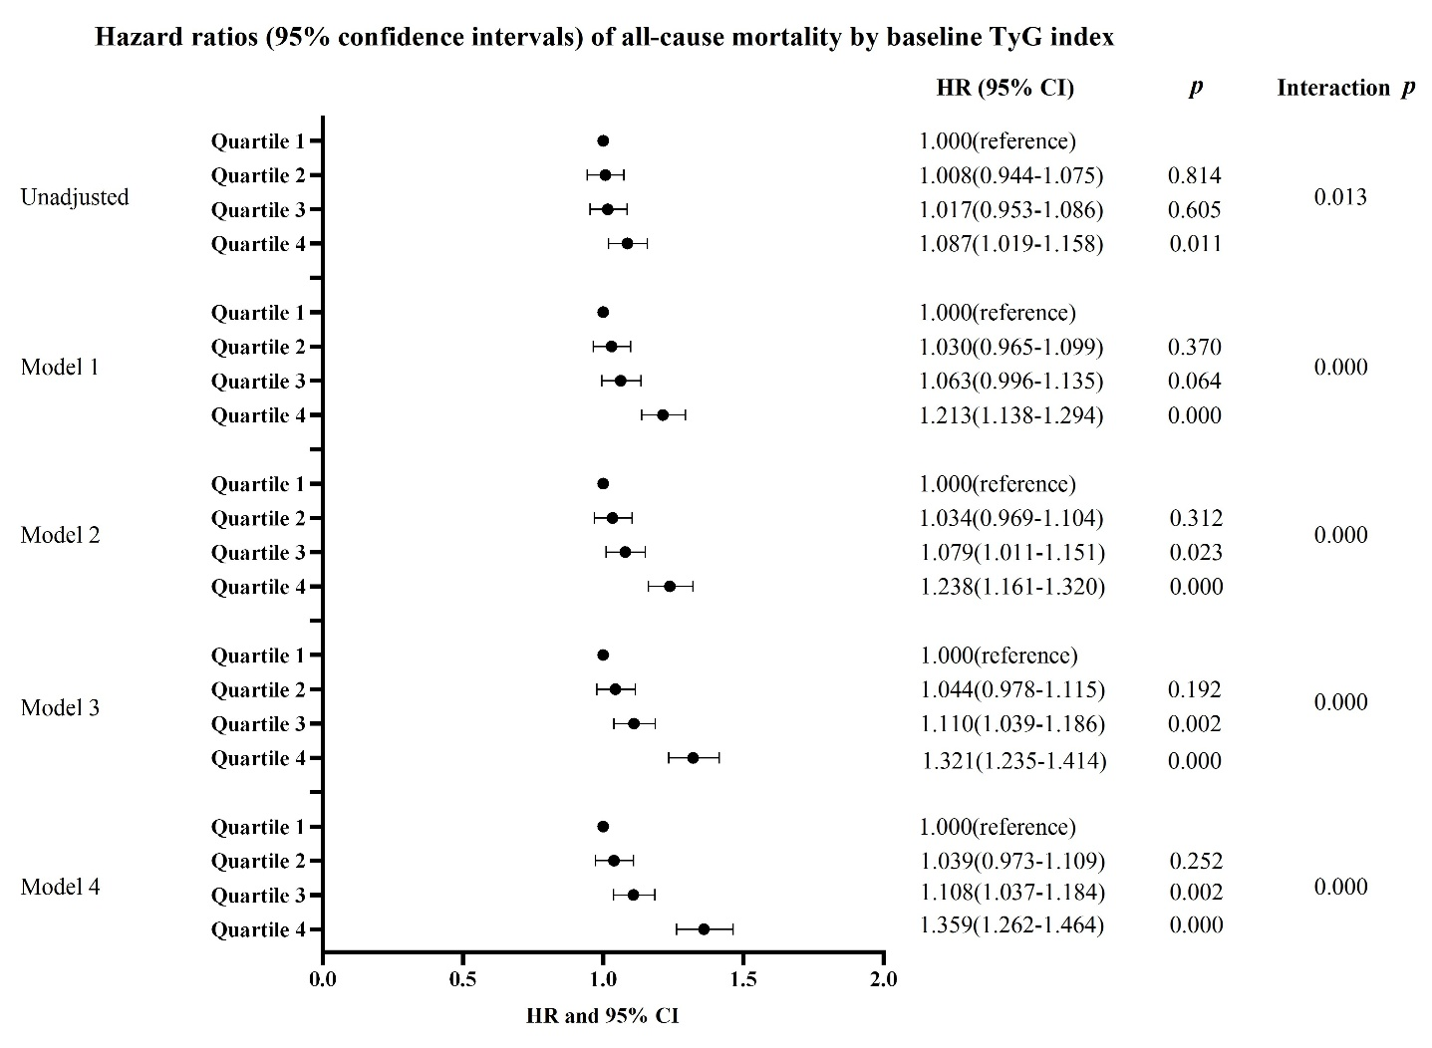
Supplementary Fig. 2: Hazard ratios (95% confidence intervals) of all-cause mortality by baseline TyG index

Supplementary Table 5: Hazard ratios (95% confidence intervals) of all-cause mortality by trajectory groups of TyG index
TyG index trajectories | Trajectory 3 | Trajectory 1 | Trajectory 2 | Trajectory 4
all-cause mortality(N)
Unadjusted  HR (95% CI) | Reference | 1.204(1.058-1.371) | 1.243(1.180-1.309) | 1.204(1.104-1.313)
p value |  | 0.005 | 0.000 | 0.000
p for trend | 0.324
Model 1  HR (95% CI) | Reference | 1.043(0.915-1.188) | 1.133(1.075-1.194) | 1.234(1.132-1.346)
p value |  | 0.528 | 0.000 | 0.000
p for trend | 0.087
Model 2  HR (95% CI) | Reference | 1.039(0.912-1.184) | 1.126(1.068-1.186) | 1.237(1.135-1.350)
p value |  | 0.564 | 0.000 | 0.000
p for trend | 0.069
Model 3  HR (95% CI) | Reference | 0.995(0.873-1.135) | 1.105(1.047-1.165) | 1.247(1.143-1.360)
p value |  | 0.942 | 0.000 | 0.000
p for trend | 0.011
Model 4  HR (95% CI) | Reference | 0.998(0.875-1.138) | 1.104(1.047-1.165) | 1.243(1.139-1.357)
p value |  | 0.972 | 0.000 | 0.000
p for trend | 0.014

Supplementary Table 6: Hazard ratios (95% confidence intervals) of all-cause mortality by trajectory groups of TyG index in different sensitivity analyses.
TyG index trajectories | Trajectory 3 | Trajectory 1 | Trajectory 2 | Trajectory 4
Sensitivity analyses 1  HR (95% CI) | Reference | 0.981(0.859-1.121) | 1.098(1.040-1.158) | 1.251(1.146-1.365)
p value |  | 0.780 | 0.001 | 0.000
Sensitivity analyses 2  HR (95% CI) | Reference | 1.030(0.893-1.186) | 1.125(1.060-1.193) | 1.255(1.139-1.383)
p value |  | 0.688 | 0.000 | 0.000
Sensitivity analyses 3  HR (95% CI) | Reference | 1.058(0.903-1.240) | 1.205(1.118-1.298) | 1.346(1.161-1.561)
p value |  | 0.483 | 0.000 | 0.000
Sensitivity Analysis 1: Delete deaths within 2 years (Model 3)
Sensitivity analysis 2: hypoglycemic drug users were excluded
Sensitivity analysis 3: Those with FBG≥7.0 and TG≥1.7 at baseline were excluded

